# Experiment Name: To determine the acceleration due to gravity applying linear least square regression method by using a simple pendulum

**Theory:**

The time period of small-angle oscillation of a simple pendulum (a metal bob attached by a light string and suspended vertically) can be shown to be



y = mx + c

where ,

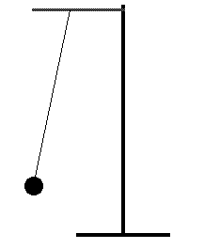 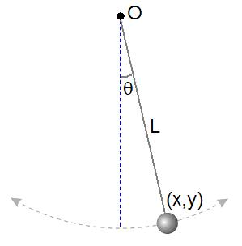

**Fig : 2**

**Fig : 1**

**Fig : simple pendulum**

where L is the length of the pendulum- the length from point of suspension to the center of the bob, g the acceleration due to gravity and slope, m = ((4π2)/g.

**Regression method :**

Considering x → the independent variable

y → dependent variable

N → number of data points.

,



The formula for determining the slope of the regression line

Best fit line y = m x + c and intercept c = y - mx

**Equipment :**

Metal bob, string, meter scale, Vernier caliper, electronic timer or a stop watch.

**Procedure :**

Attach a light piece of string to the end of a metal bob. Find the length (l) of the string with a meter stick, and the radius (r) of the bob with a caliper. The length, L, of the pendulum is then given by

L = (l + r).

Give a small angle (less than 10 degrees) swing to the pendulum. To experimentally find the time period, T, measure the total time for 30 oscillations and divide this total time by 30. T is, therefore, the time required for the pendulum to make one complete oscillation. Repeat the procedure for different lengths L. and record the data in table 1.

Plot **T2 versus L** on a graph paper. Using the Least Square Regression method, find the slope and the intercept of this linear relationship.

Using the value of the slope and the intercept, draw the regression line to your plot.

**Set**: slope = 4π2/g. Solve for g. Find % difference in g.

**Exp. No -01**

Experimental Data:

Effective Length, L = l + r =_______________ cm

Table1: Time periods for different lengths of the simple pendulum.

|  |  |  |  |  |  |
| --- | --- | --- | --- | --- | --- |
| Effective Length  L (cm) | Time for 20 oscillation  t (s) | Time period  T = t/20  (s) | T2  (s2) | L2  (cm2) | L× T2  (cm – sec2 ) |
| 150 |  |  |  |  |  |
| 140 |  |  |  |  |  |
| 130 |  |  |  |  |  |
| 120 |  |  |  |  |  |
| 110 |  |  |  |  |  |
| 100 |  |  |  |  |  |
| 90 |  |  |  |  |  |

 =  = = 

**Calculations:**

1. **The slope of the regression line from the data table:**

=

=



 =

intercept c = ‾y – m‾x =

1. **The slope of the regression line from the graph:**

slope, m = 4π2 /g

Or, =

% difference in g:

Error of g= % =

**Result: Acceleration due to gravity ‘g’ is ------------ cm/s2 or ---------- m/s2**

1. **Experiment Name: Verification of Newton's Second Law of motion by Atwood’s Machine**

**Theory:**

The acceleration of an object starting from rest, and acquiring a final velocity v in time t can be computed from the equation

D =  aex t2

or, aex =  (aex = experimental acceleration) …………… (A)

D

where, D is the distance traveled by the object during time t.

In Atwood’s machine, two masses m, and M are suspended by a piece of inelastic light string that passes over a pulley in a vertical plane. If M > m, the acceleration, a, with which the whole system moves is given by

ath =  (ath = theoretical acceleration) …………………. (B)

where g is the acceleration due to gravity (9.80 m/s2).

aex = (g / M+m) (M-m)

Fig: Atwood’s Machine

y = mx +c

slope, m = (g / M+m)

Error of a = %

**Equipment:**

Pulleys, weight hangers, weights, string, stop watch, meter stick.

**Procedure:**

Hold the lighter mass on the floor attached to one end of a string. The heavier one attached to the other end of the string is up in the air at a height D from the floor. Measure D with a meter scale.

The string runs over the pulley in the vertical plane. Now release the whole system. Measure the time the heavier mass takes to fall onto the floor. Run the experiment for 7 different mass-differences, (M - m). For each run, obtain the value of the acceleration in (m/s2) experimentally from equation (A) as well as calculate it theoretically from equation (B). Make sure to keep (M + m ~700 gm) constant.

Using EXCEL plot experimental aex versus (M - m), and find the slope of the best-fit line. Add Trend line to the plot. Set Slope = g / (M+m) and solve for (M+m). Find the % difference in (M+m)

**Exp. No -02**

Experimental Data:

**Table: Acceleration for different mass combination.**

|  |  |  |  |  |  |  |  |  |
| --- | --- | --- | --- | --- | --- | --- | --- | --- |
| M  (gm) | m  (gm) | Height  D  (cm) | Time  t  (sec) | Mean  Time  (sec) | aex =  ( cm / s2) | ath =  (cm / s2) | %  of Diff,  a= | M - m  (gm) |
| 500 | 200 |  |  |  |  |  |  |  |
|  |
|  |
| 475 | 225 |  |  |  |  |  |  |  |
|  |
|  |
| 450 | 250 |  |  |  |  |  |  |  |
|  |
|  |
| 425 | 275 |  |  |  |  |  |  |  |
|  |
|  |
| 400 | 300 |  |  |  |  |  |  |  |
|  |
|  |
| 375 | 325 |  |  |  |  |  |  |  |
|  |
|  |
| 350 | 350 |  | 0 |  | 0 | 0 | 0 | 0 |

**Calculations:**

1. **The slope of the straight line:**

From the graph-

Slope = = ………………………

or, M + m = gm

or, M +m = ---------------------------gm

1. **Error of (M+m) =** x100% =………………….

**Result:**

**Exp.No-03**

Experimental Data:

**Table 1: Readings of h, n1, n2 and t for different mass**

|  |  |  |  |  |  |  |  |  |  |
| --- | --- | --- | --- | --- | --- | --- | --- | --- | --- |
| Mass  M  (gm) | No. of  revolutions  n1 | Mean  n1 | Height  h  (cm) | Mean  (cm) | No. of  revolutions  n2 | Mean  n2 | Time  t  (s) | Mean  t  (s) | **=**  (rad /s) |
| 1000 | (1) |  |  |  | (1) |  | (1) |  |  |
| (1) |  | (1) | (1) |
| 1500 | (1) |  |  |  | (1) |  | (1) |  |  |
| (1) |  | (1) | (1) |
| 2000 | (1) |  |  |  | (1) |  | (1) |  |  |
| (1) |  | (1) | (1) |

**Table 2: Readings for radius of the axle using Vernier calipers**

**Vernier Constant of the calipers, c = --------------- mm**

|  |  |  |  |  |  |  |  |
| --- | --- | --- | --- | --- | --- | --- | --- |
| **Position** | M.S.R  x  (mm) | V.S.D  a | V.S.R  y = a.c  (mm) | Diameter  d = x+y  (mm) | Radius  r = d/2  (mm) | Mean  r  (mm) | Mean of (a) & (b)  r (cm) |
| Horizontal  (a) |  |  |  |  |  |  |  |
| Vertical  (b) |  |  |  |  |  |  |

**Calculation:**

** =**

** =**

** =**

Mean, I = 

Result:

1. **Experiment Name: Study of the Projectile Motion and Collision of a Ball.**

**Introduction:** You can sometimes get a lot of information from a small amount of data, In this experiment, you will roll a ball down a ramp and let it bounce a couple of times on the floor. You need to know the height from which the ball is released, the height of the end of the ramp, the position of the first two bounces of the ball and its mass. From this information, you will be able to determine the initial and final velocity, the initial and final kinetic energy, and the initial and final momentum – before and after the ball bounces.

**Theory:** For the two-dimensional projectile motion, the horizontal and vertical motions are independent of each other. Horizontally, projectiles in freefall travel at a constant velocity; while vertically, they experience uniform acceleration resulting in a classic parabolic trajectory. Horizontally, the only equation is , where represents the projectile's constant horizontal velocity. Vertically the projectile's initial velocity equaled zero, since it the object launched straight forward. Usually, in this situation, we let , and using the kinematics equation to solve for the time that the projectile spent in the air.

The primary goal in this experiment is to predict where the ball will land on the floor after having rolled down an incline plane. In reality, to calculate the total kinetic energy of a ball where the ball spins,

Both of these energies are measured in Joules. The moment of inertia of a solid sphere is given by the formula, . Substituting in this expression for into our equation for rotational kinetic energy yields:

as the magnitude of the velocity, .

For simplicity, during the experiment, release the ball from the top of the ramp without impart spin on the ball and the equation will be simplified as,

**Apparatus:** Marble ball/plumb ball, ramp, clamp (if needed), recording paper, carbon paper, meter scale, weight scale.

**Procedure:** Set up the apparatus as shown in Figure 1. Make sure the end of the ramp looks level with the table. Lay down a piece of recording paper on the floor and place a sheet of carbon paper on top. Each bounce of the ball will leave a mark on the recording paper.

1. Once the equipment if aligned, do not move the collision box or recording paper until the data collection is completed. However the carbon paper can be lifted at any time to inspect the collision points. Locate the position on the floor using the marble ball and measure the distance from to a reference point on the recording paper. This allows the paper to be moved after the data collection is completed to a more suitable location for the measurements of and .

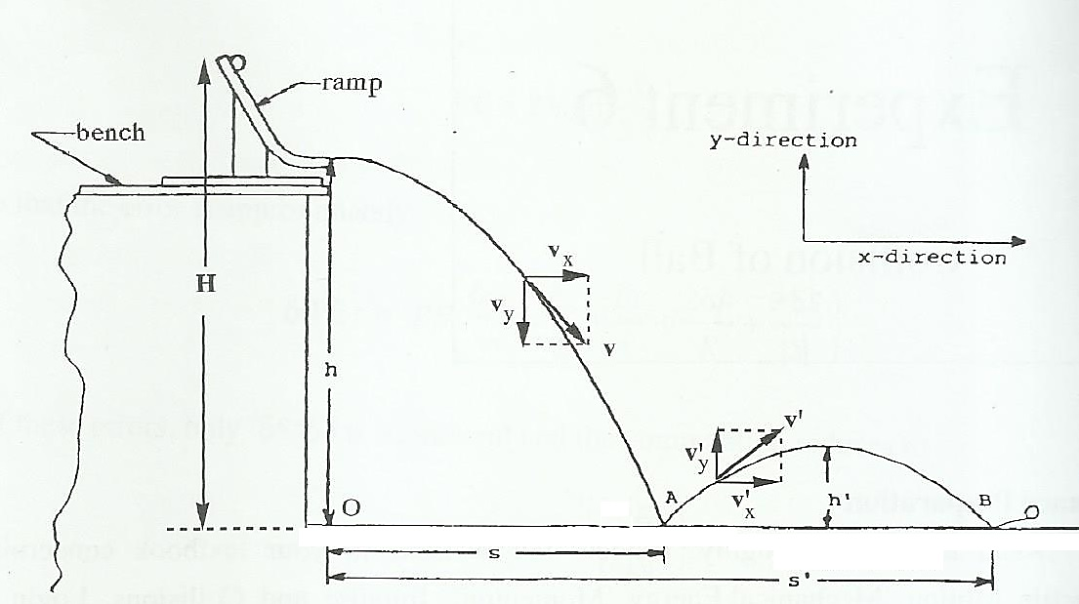

Figure 1: Experimental set-up

1. To collect the data, release the ball from a point near the top of the ramp, being careful not to impart spin on the ball. This allows the ball to roll down the ramp and bounce on the floor with minimal spin. Repeat the procedure 10 times, always releasing ball from the same point on the ramp. Measure the height of the first bounce using a meter scale.
2. Measure the height of the end of the ramp , and the height of the release position of the ball (near the top of the ramp) above the floor. Measure the mass of the ball.
3. From the recording paper, obtain the average values of and (see the Figure 1) in the following way. By eye, determine the circular region that include most of the marks on the paper (ignore any points that are obviously anomalous). Draw the circle around this region. Take the center of the circles for and . The radius of the circle as the uncertainty and , respectively.

**Analysis:** Keep in mind that the horizontal velocity of the ball before impact at equals the horizontal velocity immediately after the rebounds from . This is a good assumption providing the laboratory floor is smooth. Using your measured quantities and the value of answer the followings in the data and calculation.

**Exp. No-4**

**Experimental Data:**

|  |  |  |  |  |  |  |  |
| --- | --- | --- | --- | --- | --- | --- | --- |
| Height, H | Height, h | Height, h' | Average Distance, s | Error (Radius), | Distance, s' | Error (Radius), | Mass, m' |
|  |  |  |  |  |  |  |  |

**Calculation:**

1. Time for the ball to leave the ramp and hit point
2. Horizontal velocity of the ball as it leaves the ramp,
3. Vertical velocity just before it strikes the floor
4. Horizontal acceleration, 0
5. Time of the ball spends between point A and B,
6. Calculated maximum height,
7. Vertical velocity after it strikes point
8. Magnitude of the velocity before impact at point
9. Magnitude of the velocity **after** impact at point
10. a. Kinetic energy of the ball before the collision at

b. Kinetic energy of the ball after the collision at

1. a. What is the vertical component of momentum of the ball before

b. What is the vertical component of momentum of the ball after

1. a. What is the horizontal component of the momentum before and after

b. What is the horizontal component of the momentum before and after

1. a. What vertical impulse does the floor give to the ball?

b. What vertical impulse does the floor give to the ball?

1. a. what is the magnitude of momentum before

b. What is the magnitude of momentum after

1. a. What angle does the ball make with respect to the floor before

b. What angle does the ball make with respect to the floor after

1. **Experiment Name: To determine the Young’s modulus for the material of a wire by Searle’s apparatus**

**Experimental Data:**

**Table 1: Reading for the diameter of the wire**

Least count of the micrometer = pitch /Number of C S D = 1 mm /100 = 0.01mm = 0.001 cm

|  |  |  |  |  |  |  |  |  |  |
| --- | --- | --- | --- | --- | --- | --- | --- | --- | --- |
| No. of reading | | Liner scale reading x (mm) | Circular scale division n | Least count L.C  (mm) | Instrumental error | Circular  scale reading ± Instrumental error | Value of circular division  y = n×L.C  (mm) | Total reading x+y  (mm) | Mean  diameter  (cm) |
| 1 | (a) |  |  |  |  |  |  |  |  |
| (b) |  |  |  |  |  |  |
| 2 | (a) |  |  |  |  |  |  |
| (b) |  |  |  |  |  |  |
|  | | | | | | | | | |

**Table 2:** **Reading for the elongation of the wire**

Least count of the micrometer = Pitch /Number of C S D = 1 mm /100 = 0.01mm = 0.001 cm

|  |  |  |  |  |  |  |  |  |  |  |  |  |
| --- | --- | --- | --- | --- | --- | --- | --- | --- | --- | --- | --- | --- |
| No. of obs. | Additional load on hanger (g) | Reading for the elongation x | | | | | | | | | | Mean elongation x  (cm) |
| Load increasing | | | | | Load decreasing | | | | |
| L. S (mm) | C. S (mm) | Total  (mm) | ext.  (mm) | ext.  (cm) | L.S  (mm) | C. S  (mm) | Total  (mm) | ext.  (mm) | ext.  (cm) |
| 1 | 0 |  |  |  |  | 0 |  |  |  |  | 0 | 0 |
| 2 | 500 |  |  |  |  |  |  |  |  |  |  |  |
| 3 | 1000 |  |  |  |  |  |  |  |  |  |  |  |
| 4 | 1500 |  |  |  |  |  |  |  |  |  |  |  |
| 5 | 2000 |  |  |  |  |  |  |  |  |  |  |  |
| 6 | 2500 |  |  |  |  |  |  |  |  |  |  |  |
| 7 | 3000 |  |  |  |  |  |  |  |  |  |  |  |

Mean diameter of the wire, D =--------------------------------------- cm

Mean radius of the wire, r = ------------------------------------------ cm

Area of cross-section of the wire . r2 = --------------------------------cm2

1. **Breaking load:**

Breaking stress for the material of the wire (from Appendix of book) = ---------------- kg .wt / cm2

Breaking load = Breaking stress ×r2 = ---------------------------- kg- wt

1. **Length of the wire:**

(i) ------------------ cm (ii) ------------------- cm

Mean L = ------------------- cm

1. **Dead load on the wire = 1 kg.**

**Calculation:**

Young’s modulus,





**Result:**

1. **Experiment name: To determine the surface tension of water by capillary tube method**

**Experimental Data:**

Data for the length of the needle, = cm

**Table1:**  Readings for the needle head, R1

|  |  |  |  |  |  |  |
| --- | --- | --- | --- | --- | --- | --- |
| No.  of  obs | M.S.R  x  (mm) | V. S. D  a | V. C  c  (mm) | V.S. R  y = ac  (mm) | Total  R= x+ y (mm) | Mean  R1  (cm) |
| 1 |  |  |  |  |  |  |
| 2 |  |  |  |  |
| 3 |  |  |  |  |

**Table2:**  **Readings for the water meniscus in the tubes, R2**

|  |  |  |  |  |  |  |
| --- | --- | --- | --- | --- | --- | --- |
| No.  of  obs | M.S.R  x  (mm) | V. S. D  a | V. C  c  (mm) | V.S. R  y = ac  (mm) | Total  R= x+ y (mm) | Mean  R2  (cm) |
| 1 |  |  |  |  |  |  |
| 2 |  |  |  |  |
| 3 |  |  |  |  |

Difference of the readings between needle head and water meniscus in tube, x = (R2 ~ R1) = cm

Height h of the water meniscus in tube, h = *l* ± x = cm

**Table: 3: Measurement of radius r of the tube in the meniscus**

|  |  |  |  |  |  |  |  |  |  |  |  |  |
| --- | --- | --- | --- | --- | --- | --- | --- | --- | --- | --- | --- | --- |
| No  of obs. | ***Left side*** | | | | | ***Right side*** | | | | | Diameter  D =  x1 ~ x2  (mm) | Mean  Diameter  D  (cm) |
| M.S.R  (mm) | V.S.D | V.C.  (mm) | V.S.R  (mm) | Total  x1  (mm) | M.S.R  (mm) | V.S.D | V.C  (mm) | V.S.R  (mm) | Total  x2  (mm) |
| 1 |  |  |  |  |  |  |  |  |  |  |  |  |
| 2 |  |  |  |  |  |  |  |  |  |  |  |
| 3 |  |  |  |  |  |  |  |  |  |  |  |

Mean radius, r =  = cm

**Calculation :**

T = ( h +  ) = dynes /cm

**Results:**

**Experiment name: To determine the internal resistance of a cell using potentiometer**

**Experimental Data:**

Table: Balance point on the Potentiometer.

|  |  |  |  |  |  |  |  |  |
| --- | --- | --- | --- | --- | --- | --- | --- | --- |
| No. of Obs. | Circuit | Resistance  ohms | Value of | | | | Internal  Resistance  b ohms | Mean  b  ohms |
| l1  cm | Mean l1  cm | l2  cm | Mean l2  cm |
|  | Open | Infinity |  |  | × | × | × |  |
|  |
|  |
| 1 | Closed | 10 | × | |  |  |  |
|  |
|  |
| 2 | Closed | 20 | × | |  |  |  |
|  |
|  |
| 3 | Closed | 30 | × | |  |  |  |
|  |
|  |
| 4 | Closed | 40 | × | |  |  |  |
|  |
|  |
| 5 | Closed | 50 | × | |  |  |  |
|  |
|  |

**Calculation:**

Internal resistance b = 

(1)

(2)

(3)

**Result:**

Internal resistance = ____________________ ohm

**Experiment Name: To compare the emf of two cells using potentiometer**

**Experimental Data:**

**Table: Reading for the balance point in the potentiometer wire.**

|  |  |  |  |  |  |  |  |
| --- | --- | --- | --- | --- | --- | --- | --- |
| **No. of**  **Obs.** | **Cell** | **Null Points** | | | **Total length**  **cm** | **E1/E2 =**  **l1/l2** | **Mean**  **E1/E2** |
| **On wire**  **Number** | **Scale reading**  **cm** | **Mean**  **scale reading**  **cm** |
| 1 | First(C1) | (say 10th) |  | (say x1) | (l1=900+x1)  l1 = |  |  |
|  |
|  |
| Second(C2) |  |  |  | l2 = |
|  |
|  |
| 2 | First(C1) |  |  |  | l1 = |  |
|  |
|  |
| Second(C2) |  |  |  | l2 = |
|  |
|  |
| 3 | First(C1) |  |  |  | l1 = |  |
|  |
|  |
| Second(C2) |  |  |  | l2 = |
|  |
|  |
| 4 | First(C1) |  |  |  | l1 = |  |
|  |
|  |
| Second(C2) |  |  |  | l2 = |
|  |
|  |

Result:

The value of E1/E2 = ----------------

**Experiment name 7: To determine the temperature coefficient of resistance of the material of a wire**

**Exp.No-7**

**Experimental Data:**

Table -1: Readings balance point on meter bridge

|  |  |  |  |  |  |  |  |  |
| --- | --- | --- | --- | --- | --- | --- | --- | --- |
| Temperature | Known resistance  R  Ohms | Position of unknown resistance  X  Ohms | Balance point | | Mean  l | 100 – l | X  Ohms | Mean  X  Ohms |
| Direct current  l cm | Reverse current  l cm |
| t1 (oc) =  == |  | Left |  |  |  |  |  | **X1 =** |
| Right |  |  |  |  |  |
|  | Left |  |  |  |  |  |
| Right |  |  |  |  |  |
|  | Left |  |  |  |  |  |
| Right |  |  |  |  |  |
| t2 (oc) = |  | Left |  |  |  |  |  | **X2 =** |
| Right |  |  |  |  |  |
|  | Left |  |  |  |  |  |
| Right |  |  |  |  |  |
|  | Left |  |  |  |  |  |
| Right |  |  |  |  |  |

**Calculation:**

Using this formula find out of X

When X is in the left gap, X = 

When X is in the right gap, X = 

Temperature coefficient of resistanceα =  (where t = t2 –t1 )

**Result: __________________________ per oc**

**Experiment Name 8: To determine DC & AC voltages and frequencies using cathode ray oscilloscope**

**Purpose of this experiment**

To become familiar with the operation of a cathode-ray oscilloscope, and to use it to measure frequencies and voltages.

**Theory:**

OSCILLOSCOPE is an extremely versatile and powerful instrument that we use in electrical and electronics lab to observe time varying electronic signals.

An analog oscilloscope consists of a cathode ray tube and various circuits to deflect the cathode ray beam in the vertical or horizontal direction. The CRT has a glass envelop which is evacuated to high vacuum and a cathode which is heated to boil off electrons. The electrons emitted by the cathode are accelerated by a potential difference between the anode and the cathode and focused into a beam.

The beam produces a fine bright spot when it hits the fluorescent screen on the face of the CRT.

The electron beam can be deflected by voltages that are applied to the horizontal and vertical deflection plates.

The scope has two distinct modes of operation. In x-y mode the user supplies both the horizontal (x) and the vertical (y) deflection signals through input connectors located on the front of the scope, so that what appears on the screen is a plot of y vs x. In time base mode the time samples are drawn across the screen from left to right at a constant speed (which the user can select) while the vertical deflection is generated from an input signal supplied by the user. This makes it possible to view the input signal directly as a function of time.

**E q u i p m e n t:**

Cathode Ray Oscilloscope (CRO) , DC sources ( 1.2 V, 9 V ), Signal generator, BNC connector

**Procedure :**

Measuring D.C voltage (1.2 V and 9 V)

1. Engage the power switch and make sure the Led power is turned on. A trace appears in 20 seconds
2. Set trigger HOLD OFF to auto.
3. Adjust the trace to appropriate brightness and image with INTEN control and FOCUS control respectively.
4. Align the trace with the horizontal bottom line of the graticule by adjusting the CH1 ∇Δ POSITION control. [ If required use the trace rotate control for alignment]
5. Set the AC-DC-GND switch to DC state.
6. Set the VOLTS/DIV Dial on 0.2 V/DIV & the CH1 variable (VAR.) to calibrated ( CAL) position. [VOLTS/DIV dial tells you the number of volts to be represented by each cm of the graticule. Here each division equals 0.2 Volt.
7. Connect the Jack to CH1 INPUT terminal. The other end has 2 alligator clips. Connect the black clip to the negative terminal of a 1.2 V battery and red clip to the positive terminal.
8. The line on the oscilloscope should deflect upward. Read the number of divisions moved by the trace line and calculate the voltage. Record on the data table. [ The line should have deflected upward by about 6 Division. ]
9. Turn the Volts/Div on 0.5 and then on 1 and measure the voltage as before.

[Notice that the volts/div dial does not change the voltage.

It is a sensitivity dial that allows us to measure a wide range of voltages by telling us how much voltage is represented by each centimeter along the Y-axis.

1. Disconnect the battery from the leads on the input cables.
2. Repeat the experiment with a 9V battery with 2 and 5 volts/div

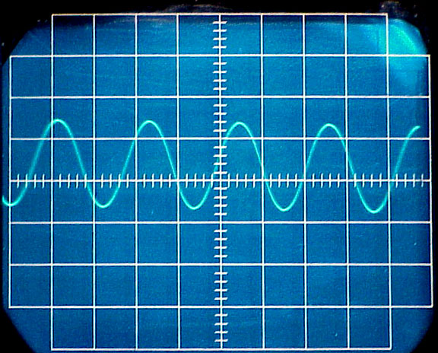

**Measuring AC voltage and frequency from Signal generator**

1. Engage the power switch and make sure the Led power is turned on. A trace appears in 20 seconds
2. Set trigger HOLD OFF to auto.
3. Adjust the trace to appropriate brightness and image with INTEN control and FOCUS control respectively.
4. Align the trace with the horizontal center line of the graticule by adjusting the CH1 POSITION
5. Set the AC-DC-GND switch to AC state.
6. Set the function generator to produce sine waves with a frequency of 100 Hz ×( 0.2- 2) and connect to the CH1 input.
7. Set the time base control to 10 ms /division, and then adjust the trigger level and the CH 1 amplitude control (CH 1 volts/div) to get a reasonable display. A waveform as shown in figure below appears in the screen.
8. Adjust the FOCUS control so that the trace image appears sharply.
9. Set the VOLTS/DIV switch and TIME/DIV switch so that signal waveform is displayed clearly.
10. Adjust ∇Δ POSITION AND ◊ POSITION control in appropriate positions so that the displayed waveform is aligned with the gratitude and voltage and period can be read conveniently.
11. Note peak to peak voltage from vertical scale.
12. Measure the distance from one peak to the next on the horizontal scale on the CRO face. That gives the period T of the AC signal; its frequency is then f = 1/T. [Thus if the dial is set for a sweep time of 10 ms/div, and you measure exactly 1 large division between two consecutive peaks of the signal], then T = 10 ms/div x 1 div = 10 ms and f = 1/T =1/(10 x 10-3 s)= 100 Hz]
13. Set the function generator to other frequencies 1k × (0.1 – 2). Set the time base control to 1ms/div to 0.2 ms/div and measure the corresponding frequencies from the CRO time base dial.
14. Set the function generator to other frequencies 10k ×(0.1 – 2). Set the time base control to 0.1ms/div to 20 μs/div and measure the corresponding frequencies from the CRO time base dial.
15. Compare the readouts from signal generator to the corresponding values obtained from CRO time base dial. Plot a Graph of frequencies observed versus the frequencies supplied by signal generator.

**Exp.No-8**

Experimental Data:

**Table1: Measuring DC voltage**

|  |  |  |  |  |  |
| --- | --- | --- | --- | --- | --- |
| BATTERY | VOLTS/DIV | POSITION OF LINE TRACE | | DEFLECTION | VOLTAGE |
|  | m | WITH NO VOLTAGE  (a) | WITH BATTERY (b) | (DIV)  d = b - a | V= m×d  (Volt) |
| 1 (1.2 V) |  |  |  |  |  |
|  |  |  |  |  |
| 2 (9V) |  |  |  |  |  |
|  |  |  |  |  |

**Table 2: Measuring AC voltage**

|  |  |  |  |  |  |
| --- | --- | --- | --- | --- | --- |
| Generator output | VOLTS/DIV | POSITION OF LINE TRACE | | DEFLECTION | VOLTAGE |
|  | m | CREST  (a) | TROUGH (b) | (DIV)  d = | b – a | | V= m×d  (Volt) |
|  |  |  |  |  |  |
|  |  |  |  |  |
|  |  |  |  |  |  |
|  |  |  |  |  |

**Table3: Measuring AC frequencies (600 Hz – 2000 Hz range)**

|  |  |  |  |  |  |  |
| --- | --- | --- | --- | --- | --- | --- |
| Generator output | | | CRO settings | | | |
| Range  r | Dial  m | f′ = r×m  Hz | TIME/DIV | PEAK TO PEAK DISTANCE | TIME PERIOD | FREQUENCY  (f) |
| M (Sec) | d = (b – a) | T = M × d (Sec) | f = 1/T (Hz) |
| 1000 | 0.6 |  |  |  |  |  |
|  | 0.8 |  |  |  |  |  |
|  | 01 |  |  |  |  |  |
|  | 1.2 |  |  |  |  |  |
|  | 1.4 |  |  |  |  |  |
|  | 1.6 |  |  |  |  |  |
|  | 1.8 |  |  |  |  |  |
|  | 2 |  |  |  |  |  |

**Table 4: Measuring AC frequencies (4000 Hz – 20000Hz range)**

|  |  |  |  |  |  |  |
| --- | --- | --- | --- | --- | --- | --- |
| **Generator output** | | | **CRO settings** | | | |
| Range  r | Dial  m | f′ = r×m  Hz | TIME/DIV | PEAK TO PEAK DISTANCE | TIME PERIOD | FREQUENCY  (f) |
| M (Sec) | d = (b – a) | T = M × d (Sec) | f = 1/T (Hz) |
| 10 k | 0.4 |  |  |  |  |  |
|  | 0.6 |  |  |  |  |  |
|  | 0.8 |  |  |  |  |  |
|  | 01 |  |  |  |  |  |
|  | 1.2 |  |  |  |  |  |
|  | 1.4 |  |  |  |  |  |
|  | 1.6 |  |  |  |  |  |
|  | 1.8 |  |  |  |  |  |
|  | 2 |  |  |  |  |  |

**Table5: Measuring AC frequencies (40000 Hz – 200000 Hz range)**

|  |  |  |  |  |  |  |
| --- | --- | --- | --- | --- | --- | --- |
| Generator output | | | CRO settings | | | |
| Range  r | Dial  m | f′ = r×m  Hz | TIME/DIV | PEAK TO PEAK DISTANCE | TIME PERIOD | FREQUENCY  (f) |
| M (Sec) | d = (b – a) | T = M × d (Sec) | f = 1/T (Hz) |
| 100 k | 0.4 |  |  |  |  |  |
|  | 0.6 |  |  |  |  |  |
|  | 0.8 |  |  |  |  |  |
|  | 01 |  |  |  |  |  |
|  | 1.2 |  |  |  |  |  |
|  | 1.4 |  |  |  |  |  |
|  | 1.6 |  |  |  |  |  |
|  | 1.8 |  |  |  |  |  |
|  | 2 |  |  |  |  |  |

**9. Experiment Name: (a) Verification of Ohm’s law using unknown resistances**

**(b) To determine the equivalent resistance for series and parallel combinations**

**Theory**: Ohm's law states that the current through a conductor between two points is directly proportional to the voltage across the two points. Introducing the constant of proportionality, the resistance, one arrives at the usual mathematical equation that describes this relationship:

I = , where V is the potential difference across the resistance R.

Rh

Rx

K

When several resistors are connected in series their equivalent resistance Rs is given by

Rs = R1 + R2 + . . . . ..

Rh

R1

R2

R2

K

Again, when the resistors are connected in parallel the equivalent resistance of their combination Rp is given by



Rh

R1 R2

**Equipment’s**: Power supply, variable resistance, ammeter, voltmeter, unknown resistance, key.

**Procedure**:

Make the above circuit. Use 2 unknown resistances R1 and R2. Using rheostat Rh choose current not more than 1 A. Vary Rh to select 10 different currents through the circuit as measured by the ammeter A. Measure the corresponding potential differences (V) in the voltmeter.

**Graphs Calculation and Result:**

Use EXCEL to plot V versus I graph. Find the best fit line. Determine the slope of the best fit line and find the values of R1 and R2. Compare with actual resistance. Find the % of difference. Now connect R1 and R2 first in series and then in parallel. Following the same procedure, determine the value of the equivalent resistances, Req, and compare these with the respective calculated values.

**Note**: You will plot 4 graphs - for R1, R2, R1 & R2 in series, and R1 & R2 in parallel.

**9. Experiment Name: (a) Verification of Ohm’s law using unknown resistances**

**(b) To determine the equivalent resistance for series and parallel combinations**

**Exp.No-9**

Experimental Data Table:

Table 1: Voltage current records for R1 and R2

|  |  |  |
| --- | --- | --- |
| R1 | **I (amp)** | **V(volt)** |
|  |  |
|  |  |
|  |  |
|  |  |
|  |  |
|  |  |
|  |  |
|  |  |
|  |  |
|  |  |
| R2 |  |  |
|  |  |
|  |  |
|  |  |
|  |  |
|  |  |
|  |  |
|  |  |
|  |  |
|  |  |

**Table 2: Voltage current records for series and parallel connections**

|  |  |  |
| --- | --- | --- |
| Resistance | I (amp) | V (volt) |
| R1 & R2 inSeries |  |  |
|  |  |
|  |  |
|  |  |
|  |  |
|  |  |
|  |  |
|  |  |
|  |  |
|  |  |
| R1 & R2 in parallel |  |  |
|  |  |
|  |  |
|  |  |
|  |  |
|  |  |
|  |  |
|  |  |
|  |  |
|  |  |

**Table – 3: (b) To determine the equivalent resistance for series and parallel combinations**

|  |  |  |  |  |  |
| --- | --- | --- | --- | --- | --- |
|  | **Resistors from the graph** | | **Calculated value** | **Experimental value from the graph** | **Comment** |
| **R1** | **R2** |
| **Equivalent resistance in series combination, Rs** |  |  |  |  |  |
| **Equivalent resistance in parallel combination, Rp** |  |  |  |

**Calculation:**

Rs = R1+ R2 =





**Experiment Name 10 : Investigation of DC voltage and frequency of a full-wave bridge-rectifier circuit**

**Purpose of this experiment**

To become familiar with the operation of a cathode-ray oscilloscope, and to know how to construct a stable output DC power supply.

**Theory:**

**OSCILLOSCOPE** is an extremely versatile and powerful instrument that we use in electrical and electronics lab to observe time varying electronic signals.

An analog oscilloscope consists of a cathode ray tube and various circuits to deflect the cathode ray beam in the vertical or horizontal direction. The CRT has a glass envelop which is evacuated to high vacuum and a cathode which is heated to boil off electrons. The electrons emitted by the cathode are accelerated by a potential difference between the anode and the cathode and focused into a beam. The beam produces a fine bright spot when it hits the fluorescent screen on the face of the CRT. The electron beam can be deflected by voltages that are applied to the horizontal and vertical deflection plates. The scope has two distinct modes of operation. In x-y mode the user supplies both the horizontal (x) and the vertical (y) deflection signals through input connectors located on the front of the scope, so that what appears on the screen is a plot of y vs x. In time base mode the time samples are drawn across the screen from left to right at a constant speed (which the user can select) while the vertical deflection is generated from an input signal supplied by the user. This makes it possible to view the input signal directly as a function of time.

A **bridge rectifier** is an arrangement of four or more diodes in a **bridge** circuit configuration (as shown in the figure) which provides the same output polarity for either input polarity. It is used for converting an alternating current (AC) input into a direct current (DC) output.

The four diodes labelled D1 to D4 are arranged in “series pairs” with only two diodes conducting current during each half cycle. During the positive half cycle of the supply, diodes D1 and D2 conduct in series while diodes D3 and D4 are reverse biased and the current flows through the load as shown below.

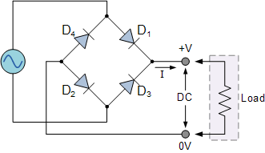

**The Positive Half-cycle :** During the positive half cycle of the supply, diodes D1 and D2 conduct in series, but diodes D3 and D4 switch “OFF” as they are now reverse biased. The current flowing through the load is in a direction as shown in the figure.

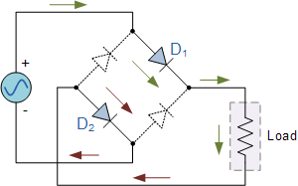

**The Negative Half-cycle :** During the negative half cycle of the supply, diodes D3 and D4 conduct in series, but diodes D1 and D2 switch “OFF” as they are now reverse biased. The current flowing through the load is the same direction as before.

As the current flowing through the load is unidirectional, so the voltage developed across the load is also unidirectional the same as for the previous two diode full-wave rectifier, therefore the average DC voltage across the load is 0.637Vmax.

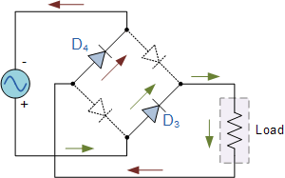However in reality, during each half cycle the current flows through two diodes instead of just one so the amplitude of the output voltage is two voltage drops (2 x 0.7 = 1.4V ) less than the input VMAX amplitude. The ripple frequency is now twice the supply frequency (e.g. 100Hz for a 50Hz supply or 120Hz for a 60Hz supply.)

**The Smoothing Capacitor**

We saw in the previous section that the single-phase half-wave rectifier produces an output wave every half cycle and that it was not practical to use this type of circuit to produce a steady DC supply. The full-wave bridge rectifier however, gives us a greater mean DC value (0.637 Vmax) with less superimposed ripple while the output waveform is twice that of the frequency of the input supply frequency.

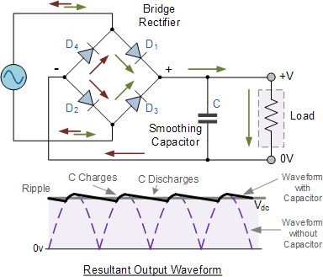We can improve the average DC output of the rectifier while at the same time reducing the AC variation of the rectified output by using smoothing capacitors to filter the output waveform. Smoothing or reservoir capacitors connected in parallel with the load across the output of the full wave bridge rectifier circuit increases the average DC output level even higher as the capacitor acts like a storage device as shown below. The smoothing capacitor converts the full-wave rippled output of the rectifier into a more smooth DC output voltage.

**Equipment:**

Cathode Ray Oscilloscope (CRO) , BNC connector , Transformer, Diodes, Resistor, Capacitor.

**Procedure:**

1. **Measuring AC voltage & frequencies for different outputs of the transformer:**
2. Engage the power switch and make sure the Led power is turned on. A trace appears in 20 seconds
3. Set trigger HOLD OFF to auto.
4. Adjust the trace to appropriate brightness and image with INTEN control and FOCUS control respectively.
5. Align the trace with the horizontal center line of the graticule by adjusting the CH1 POSITION
6. Set the AC-DC-GND switch to AC state.
7. Connect the Jack to CH1 INPUT terminal. The other end has 2 alligator clips. Connect the black clip to the negative terminal of the transformer and red clip to the transformer output no. 1or 2 or 3 or 4 or 5 .
8. Set the time base control to 10 ms/division, and then adjust the trigger level and the CH 1 amplitude control (CH 1 volts/div) to get a reasonable display. A waveform as shown in figure below appears in the screen.
9. Adjust the FOCUS control so that the trace image appears sharply.
10. Set the VOLTS/DIV switch and TIME/DIV switch so that signal waveform is displayed clearly.
11. Adjust ∇Δ POSITION AND ◊POSITION control in appropriate positions so that the displayed waveform is aligned with the graticule and voltage and period can be read conveniently.



1. Note peak to peak voltage from vertical scale.
2. Measure the distance from one peak to the next on the horizontal scale on the CRO face. That gives the period T of the AC signal; its frequency is then f = 1/T. [Thus if the dial is set for a sweep time of 10 ms/div, and you measure exactly 1 large division between two consecutive peaks of the signal, then

T = 10 ms/div x 1 div = 10 ms

And f = 1/T =1/(10 x 10-3 s)= 100 Hz]

1. **Measurement of the output voltage and frequency of the full wave rectifier circuit:**
2. Connect the transformer outputs (no. 1or 2 or 3 or 4 or 5) to the bridge rectifier circuit and connect the Jack to CH1 INPUT terminal. Connect the black clip and red clips with the two terminals of the load resistor.
3. Set the time base control to 10 ms/division, and then adjust the trigger level and the CH 1 amplitude control (CH 1 volts/div) to get a reasonable display. A waveform as shown in figure below appears in the screen.

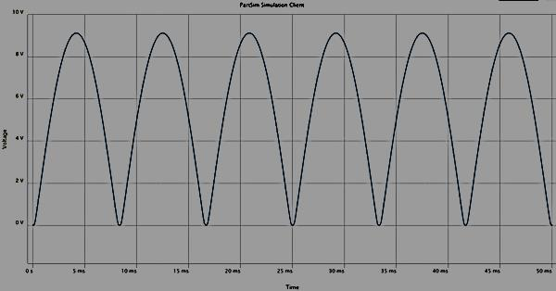

1. Adjust the FOCUS control so that the trace image appears sharply.
2. Set the VOLTS/DIV switch and TIME/DIV switch so that signal waveform is displayed clearly.
3. Adjust ∇Δ POSITION AND ◊POSITION control in appropriate positions so that the displayed waveform is aligned with the graticule and voltage and period can be read conveniently.
4. Note peak to peak voltage from vertical scale.
5. Measure the distance from one peak to the next on the horizontal scale on the CRO face. That gives the period T of the AC signal; its frequency is then f = 1/T. [Thus if the dial is set for a sweep time of 10 ms/div, and you measure exactly 1 large division between two consecutive peaks of the signal, then

T = 10 ms/div x 1 div = 10 ms and f = 1/T =1/(10 x 10-3 s)= 100 Hz]

1. **Measurement of the output dc voltage full wave rectifier circuit with filter:**
2. Connect the transformer outputs (no. 1or 2 or 3 or 4 or 5) to the bridge rectifier circuit and connect the capacitor with the load resistor. Now connect the Jack to CH1 INPUT terminal. Connect the black clip and red clips with the two terminals of the load resistor.
3. Set the AC-DC-GND switch to DC state.
4. Set the VOLTS/DIV switch so that signal waveform is displayed clearly.
5. 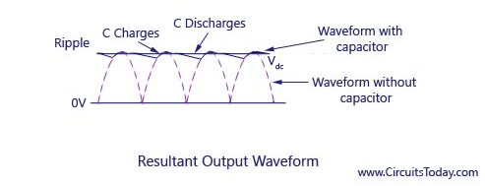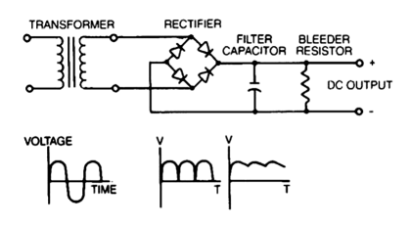Adjust ∇Δ POSITION AND ◊POSITION control in appropriate positions so that the displayed waveform is aligned with the graticule and voltage can be read conveniently.

**Exp.No-10**

**Table 1: Measuring AC voltage & frequencies**

|  |  |  |  |  |  |  |  |  |  |
| --- | --- | --- | --- | --- | --- | --- | --- | --- | --- |
| **Voltage** | | | | | | **Frequencies** | | | |
| Transformer output | Volts/Div | Position of Line Trace | | Deflection | Voltage | Time/Div | Peak to Peak Distance | Time Period | Frequency  (f) |
|  | m | Crest  (a) | Trough (b) | (DIV)  d =| b – a| | V=m×d  (Volt) | M | d = (b –a) | T = M × d (Sec) | f = 1/T (Hz) |
| 1 |  |  |  |  |  |  |  |  |  |
| 2 |  |  |  |  |  |  |  |  |  |
| 3 |  |  |  |  |  |  |  |  |  |
| 4 |  |  |  |  |  |  |  |  |  |
| 5 |  |  |  |  |  |  |  |  |  |

**Table-2: Full wave Rectifier circuit**

|  |  |  |  |  |  |  |  |  |  |  |
| --- | --- | --- | --- | --- | --- | --- | --- | --- | --- | --- |
| **Voltage** | | | | | | | **Frequencies** | | | |
| Transformer output | Volts/Div | Position of Line Trace | | Deflection | Voltage  Vmax |  | Time/Div | Peak to Peak Distance | Time Period | Frequency  (f) |
|  | m | CREST  (a) | With  No Voltage (b) | (DIV)  d =| b-a| | Vmax= m×d  (Volt) | Vdc = | M | d = (b – a) | T = M × d (Sec) | f = 1/T (Hz) |
| 1 |  |  |  |  |  |  |  |  |  |  |
| 2 |  |  |  |  |  |  |  |  |  |  |
| 3 |  |  |  |  |  |  |  |  |  |  |
| 4 |  |  |  |  |  |  |  |  |  |  |
| 5 |  |  |  |  |  |  |  |  |  |  |

**Table-3: Rectifier circuit with filter**

|  |  |  |  |  |  |
| --- | --- | --- | --- | --- | --- |
| Transformer output | VOLTS/DIV | POSITION OF LINE TRACE | | DEFLECTION | VOLTAGE |
|  | m | With No Voltage (a) | With voltage (b) | (DIV)  d =| b – a| | V= m×d  (Volt) |
| 1 |  |  |  |  |  |
| 2 |  |  |  |  |  |
| 3 |  |  |  |  |  |
| 4 |  |  |  |  |  |
| 5 |  |  |  |  |  |

**Experiment Name 11: To determine the RC time constant in an RC circuit**

**Theory: Charging a capacitor**

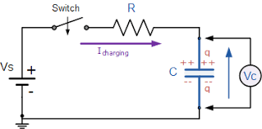

Fig 1 : Charging a capacitor

Kirchhoff’s loop theorem:

– iR - = 0

= iR + [i & q = two variables, i = ]

=

q = C(1 – )

CVc = C(1 - ) [q = CVc]

Vc = (1 – )

= 1 -

=

= -

= (-)t

From the graph, y = mx + b

Slope, m = (-)

**Discharging a capacitor:**

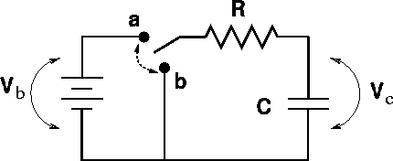

Fig 2: Discharging a capacitor

Kirchhoff’s loop theorem:

[ i = ]

q = C

CVc = C [q = CVc]

Vc =

From the graph, y = mx + b

Slope, m = (-)

**Apparatus:** Resistor, capacitor, power supply, voltmeter and stop watch

1. **. Experiment Name: To determine the RC time constant in an RC circuit**

**Exp.No-11**

Charging & Discharging of an RC circuit

Maximum potential difference () =

|  |  |  |  |  |
| --- | --- | --- | --- | --- |
| Time (s) | **Charging capacitor** | | **Discharging capacitor** | |
| (volt) | In (1 - | (volt) | In |
| **0** | **0** |  |  |  |
| **15** |  |  |  |  |
| **30** |  |  |  |  |
| **45** |  |  |  |  |
| **60** |  |  |  |  |
| **75** |  |  |  |  |
| **90** |  |  |  |  |
| **105** |  |  |  |  |
| **120** |  |  |  |  |
| 150 |  |  |  |  |
| 180 |  |  |  |  |
| 210 |  |  |  |  |
| 240 |  |  |  |  |
| 270 |  |  |  |  |
| 300 |  |  |  |  |
| **360** |  |  |  |  |
| **420** |  |  |  |  |
| **480** |  |  |  |  |
| **540** |  |  |  |  |
| **600** |  |  |  |  |
| **660** |  |  |  |  |
| **720** |  |  |  |  |
| **780** |  |  |  |  |
| **840** |  |  |  |  |
| **940** |  |  |  |  |

**Calculation: Charging a capacitor**

**Theoretically:**

**Time constant,**

**Experimentally:**

From the graph: Slope, m =

Error of

**Calculation: Discharging a capacitor**

**Theoretically:**

**Time constant,**

**Experimentally:**

From the graph: Slope, m =

Error of

**American International University-Bangladesh (AIUB)**

**Section: ……… Semester: ………………….**

**Lab Report**

**Physics Lab-1**

**Experiment No.: ………...**

**Name of the Experiment: ………………………..........................**

**……………………………………………………………………………….**

**………………………………………………………..............................**

**Group Number: …….**

|  |  |
| --- | --- |
| **Names of the Students:** | **ID Numbers:** |
| **1.** |  |
| **2.** |  |
| **3.** |  |
| **4.** |  |

**Date of the Experiment: ………………**



**AMERICAN INTERNATIONAL UNIVERSITY-BANGLADESH**

Faculty of Science and Information Technology

Department of Physics

Program: B.Sc. (EEE/COE/CSE/CSSE/CS/SE)

**COURSE OUTLINE Semester: Spring 2019-20**

**I - Course Code and Title: PHY 1102**  **Physics 1 LAB**

**II - Credit: 1**

**III- Course Description:**

|  |
| --- |
| Undergraduate labs are designed to reinforce information presented during course lectures by providing students "hands-on" opportunities to explore the concepts and principles of physics taught in the course Physics 1. Topics include: determination of acceleration due to gravity using a simple pendulum; determination of projectile motion and collision of a ball; verification of Newton’s second law of motion by Atwood’s machine; moment of inertia of a fly-wheel about its axis of rotation; Young’s modulus of a wire using Searle’s apparatus; measuring the surface tension of water using capillary tube method; verification of Ohm’s law and verification of the laws of series and parallel combinations of resistances; temperature co-efficient of resistance of a wire; To determine DC & AC voltages and frequencies using cathode ray oscilloscope; Investigation of DC voltage and frequency of a full-wave bridge-rectifier circuit; To determine the RC time constant in an RC circuit; internal resistance/emf of a cell. |

**IV – Objectives:**

|  |
| --- |
| **Course Objective** |
| * In subjects like Physics, the laboratory work, popularly known as practical classes, is no less important than the theoretical lectures. In performing an experiment in the laboratory, students are required to revise thoroughly the ideas and the principles involved in the experiment which were explained by the teachers in the theoretical classes. Thus practical classes serve as a sort of revision exercises of the theoretical lectures and at the same time provide students a hands-on-experience about the underlying principles of the theoretical knowledge gained in the theory classes. * Moreover, laboratory work provides students a training to present scientific and experimental data in a methodical and coherent fashion which is very much needed for future writing of scientific [or technical ] reports and papers. * An important goal of this course is to introduce the practical demonstration of the physical laws and theories taught in the course Physics 1. * Students learn the methods of experiments to measure unknown quantities and draw conclusion from them. * At the same time they develop skills in applying different tools such as mathematical or statistical or even calculator / computer, etc. |

**V– List of Experiments:**

|  |  |  |
| --- | --- | --- |
| **Serial**  **No.** | **Midterm Exam** | **Teaching Strategy** |
| 1 | To determine the acceleration due to gravity applying linear least square regression method by using a simple pendulum | After demonstrating the basic principles and salient features of the experiment, students are allowed to use apparatus for performing the experiment. |
| 2 | Verification of Newton’s second law of motion by Atwood’s machine |
| 3 | To determine the moment of inertia of a fly-wheel about its axis of rotation |
| 4 | To determine the projectile motion and collision of a ball |
| 5 | To determine the Young’s modulus for the material of a wire by Searle’s apparatus |
| 6 | To determine the internal resistance of a cell by using potentiometer and to compare the emf of two cells |
|  | **Final Exam** |  |
| 7 | To determine the temperature coefficient of resistance of the material of a wire |
| 8 | To determine DC & AC voltages and frequencies using cathode ray oscilloscope |
| 9 | (a) Verification of Ohm’s law using unknown resistances  (b) To determine the equivalent resistance for series and parallel combinations |
| 10 | Investigation of DC voltage and frequency of a full-wave bridge-rectifier circuit |
| 11 | To determine the RC time constant in an RC circuit |
| 12 | To determine the surface tension of water by capillary tube method |
|  |

**VI - Course Requirements:**

|  |
| --- |
| 1. Must attend all the lab classes. 2. Make up can be done for only one missed lab for legitimate reason. 3. Must appear at the midterm and the final lab examinations.   4. Students must have 80% attendance to pass the course. |

**VII – Evaluation:**

|  |  |  |
| --- | --- | --- |
| **Evaluation:** | | |
| **Mid term** | Lab attendance / Participation | 10 |
| Lab performance | 10 |
| Lab report [Group wise] | 40 |
| Lab midterm examination | 30 |
| Lab viva [Last week] | 10 |
| Total | 100 |
| **Final term** | Lab attendance / Participation | 10 |
| Lab performance | 10 |
| Lab report [Group wise] | 40 |
| Lab final examination | 30 |
| Lab viva [Last week] | 10 |
| Total | 100 |
| **Grand Total** | 40% of Midterm + 60% of Final Exam | |

**VIII – Textbook/ Reference Materials:**

|  |
| --- |
| 1. Practical Physics- Dr. Giasuddin Ahmed will be used as laboratory manual book 2. Electronic copy of Manuals uploaded in UMS |
| **INTERNET ACCESS IS REQUIRED:**  The VUES website will be used throughout the course for the posting of announcements, and test marks. Students can access the website through their university account. |

**PHYSICS LAB**

**AMERICAN INTERNATIONAL UNIVERSITY-BANGLADESH (AIUB)**

**FACULTY OF SCIENCE & IT**

**GENERAL INSTRUCTIONS**

***PRELAB HOMEWORK***

* The Assignment for each lab is counted as Pre lab Home work.
* The student should prepare the lab write-up including Title page, Theory, Required Apparatus, Procedure, Data headings at home as per instructions of the lab teacher.
* There will be a Penalty for incomplete lab write-up.

***INSIDE THE LAB***

* **ENTER LABORATORY** within 5 minutes of the scheduled time.
* Keep your bag on the shelf.
* Do not keep any valuable items in the bag. In case of any theft, the authority will not be responsible.
* Switch off the mobile phone.
* The course teacher gives a lecture on the experiment.
* One member from each group collects apparatus from the lab assistant by submitting his/her ID card.
* All the groups make necessary preparation to perform the experiment.
* The course teacher demonstrates the different steps of the experiment.
* Students perform the experiment in groups, record data, etc.
* The teacher verifies the data obtained by each group from time to time.
* Do calculations & analysis [graph drawing etc.] of the results obtained and finish the writing of the lab report.
* Return the apparatus to the lab assistant.
* Submit the report to the course teacher.
* Remember, if any instrument/apparatus is damaged or lost, it is to be replaced by the concerned group.
* LAB ENDS

***GRADING SYSTEM***

* Lab attendance / Participation 10%
* Lab Report 40%
* Lab performance 10%
* Lab examination 30%
* Lab viva 10%
* Grading policy of AIUB will be followed
* There are currently about (10) 3-hour labs per course.
* Each laboratory experiments typically count about 8-10% (DEPENDING ON COURSE INSTRUCTOR/ NUMBER OF AVAILABLE CLASSES) of the grade.
* There will be 2 point for each Attendance. [5 lab classes]
* There will be 1 point penalty for every late attendance (5 – 15 minutes)
* There will be a penalty for late labs reports.
* The student must attend all the lab classes to pass the course.

***LAB REPORTS***

* Lab reports are due on the day of the experiment.
* Deposit reports after doing the experiment.
* Again, there will be a grading penalty for late lab reports.
* Attendance in the lab is mandatory.

***LAB PARTNERS***

* There are on an average 4 (sometimes 5) students per setup.

***DATA SHEETS***

* The students must have their data sheets signed by the Lab teacher prior to leaving the lab.
* The data sheets should show the names of the laboratory partners on every page.

***MISSED LABS***

* If you miss a Lab, contact the concerned Lab teacher to have his/her permission for a makeup Lab.
* If permitted, arrange with the Lab assistant to attend another session within one week of the missed lab.
* Unless there is a legitimate reason, makeup labs will be counted as late labs.
* No Lab report will be accepted without the signature [with date] of the teacher with whom this Lab makeup experiment was performed.

***LAB MANUAL***

1. Practical Physics - Dr. Giasuddin Ahmed will be used as a laboratory manual book